|  |
| --- |
| Experiment - 2 |

* **Title**: Macros and Protected Workbook.
* **Macros** :- Macros in MS Excel are essentially recorded sequences of actions that automate tasks. They are created using the Visual Basic for Applications (VBA) programming language and allow users to automate repetitive tasks or perform complex operations with a single click.
* Key points about macros in MS Excel:

1. **Automation**: Macros automate repetitive tasks by recording a series of actions performed by the user and then playing them back upon request.
2. **Time-saving**: They save time by eliminating the need to manually perform repetitive tasks, such as formatting data, generating reports, or performing calculations.
3. **Customization**: Macros can be customized to perform specific actions or tasks tailored to the user's needs. This allows for greater efficiency and productivity in Excel workflows.
4. **Versatility**: Macros can be applied to various tasks, from simple operations like data formatting to more complex tasks involving data analysis and manipulation.
5. **Record and Playback**: Users can record their actions in Excel, and the macro recorder generates VBA code based on these actions. This code can then be edited or enhanced as needed.
6. **Programming**: Advanced users can write macros directly in VBA, allowing for greater flexibility and control over the automation process. This enables the creation of more sophisticated macros to handle complex tasks.
7. **Integration**: Macros can be integrated with other Microsoft Office applications, allowing for seamless automation across the entire Office suite.

* Overall, macros in MS Excel provide a powerful tool for automating tasks, improving efficiency, and streamlining workflows within Excel.
* **Steps to Record & Apply Macros**: Here's a step-by-step guide:
  1. Enable Developer Tab.

* 1. **Record Macro**: Developer tab > Record Macro > Name it > Perform actions > Stop Recording.

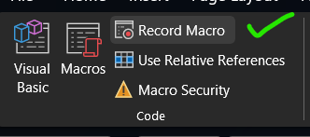

* 1. **Run Macro**: Developer tab > Macros > Select > Run.

* 1. **Save Workbook with Macros**: File > Save As > Choose location > Select "Excel Macro-Enabled Workbook (*.xlsm)" > Save.
* **Protected Workbook**: In Microsoft Excel, a protected workbook is a file that has been secured to prevent unauthorized users from making changes to its structure, such as adding, deleting, or modifying sheets, as well as editing certain elements like formulas and formatting.
* Key points about protected workbooks:

1. **Protection**: When a workbook is protected, users can still view and interact with its contents, but they are restricted from making certain changes without the correct password.

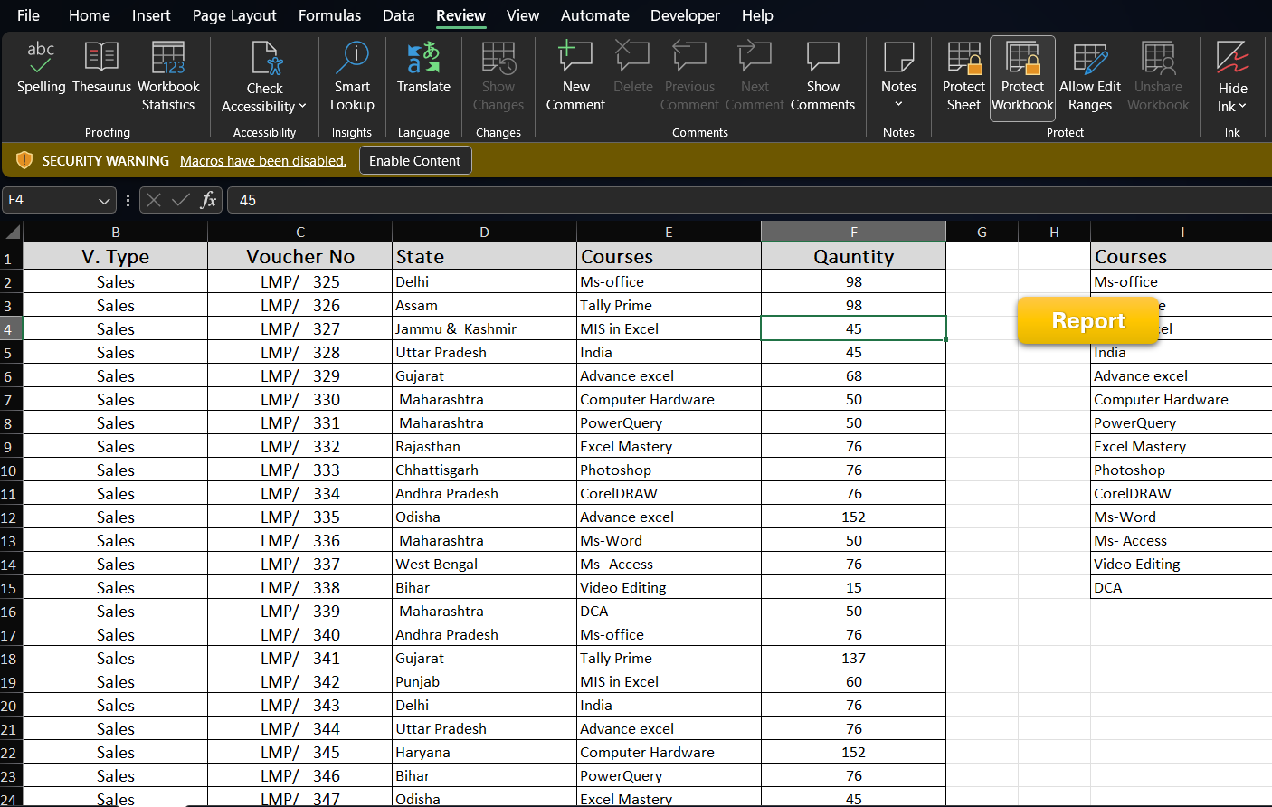

1. **Purpose**: Protecting a workbook helps maintain data integrity and prevents accidental or intentional modifications that could affect the accuracy or functionality of the spreadsheet.

1. **Protection Options**: Excel offers various protection options, including protecting the entire workbook, individual sheets, or specific elements like cells or formulas.

4. **Password**: To unlock a protected workbook or make changes to protected elements, users must enter the correct password set by the workbook creator or administrator.

5. **Limitations**: While protected workbooks provide a level of security, it's important to note that protection can be circumvented by individuals with sufficient knowledge or by using specialized software.

* Overall, protecting a workbook in Excel helps safeguard its contents and structure, ensuring that only authorized users can make changes as needed.